**“Head” in next.js**

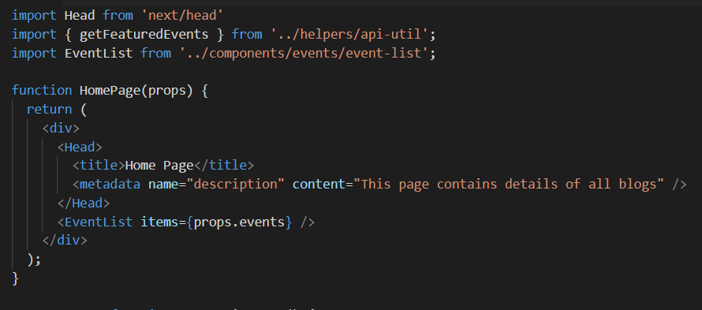

To set a nav bar in all pages use _app.js file. “Component” and “pageProps” are to be used as is.

We can also add <Head> in this file and this will be set across all pages. If content in <Head> conflicts from content _app.js to page file then latest one will be considered( e.g: containing 2 <title> tags)

Import Head from next/head

Whatever is given inside <Head> will be set to <head> tag in html page

We can set “title” which will set the title on the tab in chrome. All we can set in html page can be set here as well.

In “Head”, H should be capital

This Head can be set in any page, when that page is loaded this Head will be added.

We can also dynamically generate content in <Head> as we have access to props

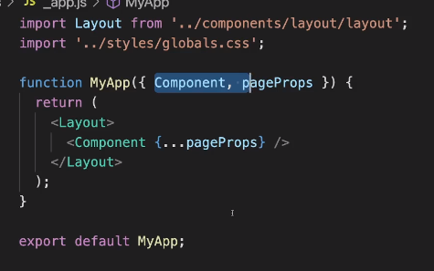 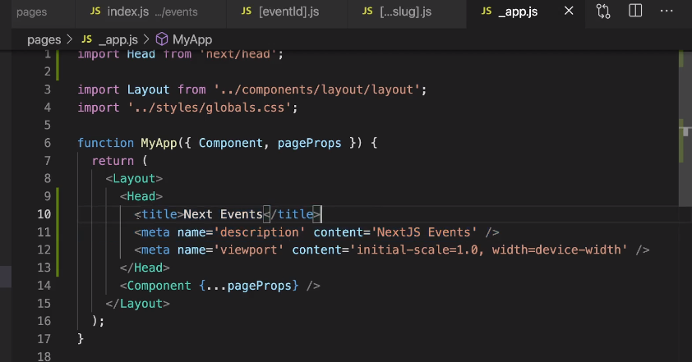

**_document.js file**

This _document.js file like _app.js but is separated with other components. “Head” that is imported from next/document is different from “Head” imported from next/head.

Here we can see whatever is given in <Html> is added to <html> tag in source code.

<div> that we added under <body> in _document.js file is added to <body> tag in source code. This #id can used to create portlets and popups



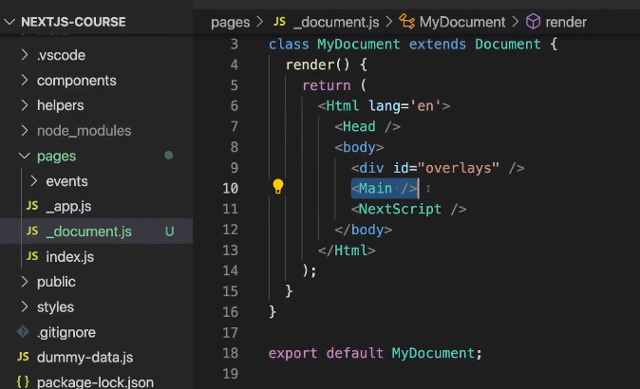 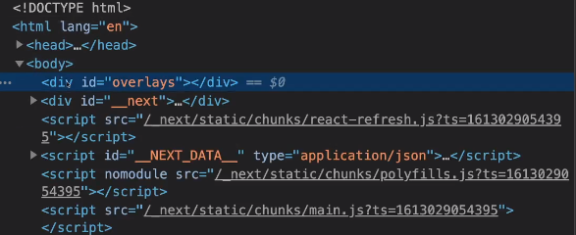

**Images**

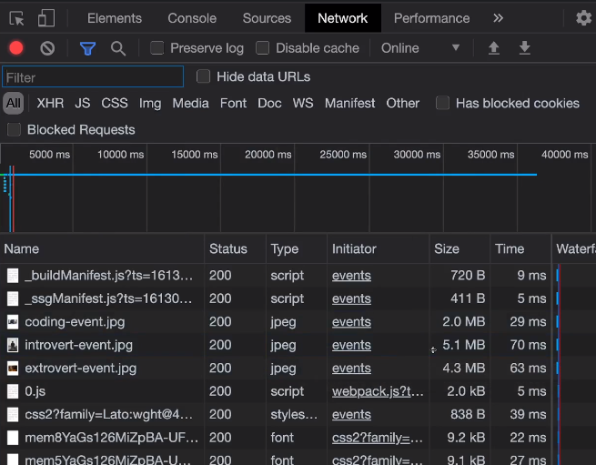

From the left image we can see that images are loaded as is. Therefore image type is .jpeg and size is in MBs

If we change the <img> tag to <Image> tag imported from “next/image” then we can see that image type is changed to “webp” and size is also reduced to KBs.

We need to give “width” and “height” props to the <Image” component. This the size of the image to be loaded in screen, not the original size of the image.

Other feature we get is “lazy load”. Request is made to get the image only when that image should be shown in the screen. i.e when an image in the bottom and will not be shown when screen is loaded, then it will not fetch that image. But when we scroll down to that part of the page, request is made to get that image.





